Rail Safety Week Social Report
(Data from Sept. 16 to Sept. 30, 2018)

- Total Messages: 52
  - This includes BLE Facebook, CATS Main Facebook, CATS Main Twitter, BLE Twitter, Gold Line Twitter and Gold Line Facebook
- Total Impressions: 40,279
  - Twitter Total: 27,681
  - Facebook Total: 12,598
- Reach
  - Facebook: 9,196
- Total Engagements: 142
  - Total Clicks: 57
  - Twitter
    - Retweets: 9
    - Likes: 59
    - Clicks: 30
  - Facebook:
    - Reactions: 50
    - Comments: 11
    - Shares: 13
    - Clicks: 27
- Highest Day of Engagement and Impressions: September 26
  - Highest Tweets:
    - We’re out at UNC Charlotte Main LYNX Station talking to students about rail safety! #RailSafetyWeek pic.twitter.com/i64GJOC193
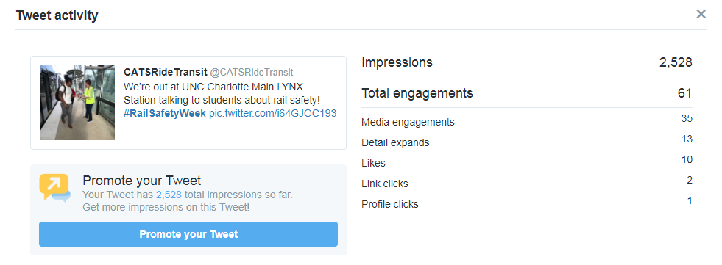
    - Team @CLTgov participated in #WearGreenForRailSafety! Did you?! Show us your green in honor of Rail Safety Week! Learn more about how to be safe near the tracks at http://safety.ridetransit.org . pic.twitter.com/TNSkyjloU7
